-Department of Engineering and Digital Technologies

Name Oyinkansola Afolabi

UB Number 22050542

Email Address: o.i.afolabi@bradford.ac.uk

Requirements Specification Document

Yorkshire & Humber Regional Organized Crime Unit: Workflow Management System

# Introduction

An enterprise information system called a workflow management system makes sure that work may be automatically assigned by a computer system to resources, including people and apps, in line with a predetermined schema of the process, the resources that are accessible, and their dependencies. (Reijers et al., 2016)

Typically, FireSwitch Tech, a Nigerian tech hub that offers a range of IT project services to businesses, was consulted. Among its clientele are Toluade photographic – a photographic company, Eclipse – a logistics company, and Abulesowo – a real estate company, among numerous others. It was learned from a WhatsApp discussion with their customer support representative that calls and paperwork were the conventional methods of handling most organizational workflow process. Traditionally, the CEO or admin would hold a meeting with the supervisor and the employees who would be handling the tasks. Based on the nature and duration of the assignment, subcommittees would be assigned from the meeting to provide supervisors with updates on a weekly, monthly, or quarterly basis. The CEO would receive the final report from the manager or supervisor. The manager would be in charge of overseeing the assignment, which would need a lot of paperwork, multiple meetings, and a lot of time spent on reports and filing. This procedure may take a lot of time, waste money, result in missed appointments, excessive wait times, and incorrect scheduling.

Businesses need to implement an automated workflow system that enables managers and staff to oversee workflows online in order to address these problems. Any internet-connected device, including PCs, tablets, and smartphones, should be able to access these systems.

Studies by Bowers et al. (1995), Dourish (2001), and Schmidt et al. (1999) show that an organization's operational performance is enhanced by a workflow management system. Goebl, et al. (2001) reported that their workflow management system reduced the total lead time by 70% following the introduction of electronic data and task routing automation. According to Küng and Hagen (2007), the installation of a workflow management system for a Swiss bank resulted in a decrease in lead times, an increase in output per employee, and better work quality for a number of operations.

**Project Selection Reasons:**

The Yorkshire and Humber Regional Organised Crime Unit (YHROCU) decided to deploy a web-based workflow management system for non-crime related operations based on a number of important considerations:  
  
Enhancement of Operational Efficiency: The YHROCU oversees a variety of support functions that are essential to its daily operations. Putting in place a thorough workflow management system will increase task delegation, optimise workflows, and boost overall operational effectiveness. The system is designed to optimise resource allocation and guarantee timely task completion through the automation of task assignment, tracking, and reporting.

Better Task Management: The efficiency and visibility of the present manual task management procedures are lacking. Tasks can be easily assigned to individuals or collaborative teams using a web-based system, and staff members will receive automated email notifications as soon as a work is assigned. Updates on task status, due dates, and progress will be possible for users, enabling real-time communication and cooperation.   
  
Enhanced Supervisory Oversight: By giving supervisory staff complete visibility into every task, the system will enable efficient workload distribution and supervision. Supervisors have access to work specifics, can keep an eye on developments, and can step in as needed to clear bottlenecks or distribute resources effectively. Ensuring the confidentiality of sensitive information while fostering accountability and transparency is made possible by the control over task visibility.

**Skillsets:**

My skillsets encompass a broad range of technical, soft, domain-specific, and personal development skills, including proficiency in programming languages such as Python, Java, and JavaScript. In addition to your coding abilities, you possess expertise in web development frameworks like Django and React, alongside strong skills in data analysis using tools like Pandas and NumPy.

# 

# Features of the System

By using software to automate the workflow system of an organization, tasks and projects can be managed more efficiently. This system has the necessary features to act as both a task management system and an independent software system. It allows the user to manage tasks, their status, due dates, and reviews. It also allows the user to enter progress updates into a rolling log. To ensure the efficient operation and seamless operation of the company, the administrator can also designate roles and tasks to individual employees. The purpose of the application is to manage tasks, people, processes, and projects.

A workflow management system has shown to be beneficial in a variety of industries, an example is the the healthcare industry (Halsted and Froehle, 2008). The system developed by Li et al. (2013) markedly reduced patient wait times, the average number of patients in waiting rooms, and the number of patients treated each month. Additionally, patient satisfaction rose, and staff workload stress dropped. According to the study by Reijer and Van der Aast (2005), 12 out of 16 cases show a considerable decline in the anticipated service time, ranging from 4% to 47%. Automation of organizational workflow can not only increase productivity and boost user happiness, but it can also lighten the workload of employees.

**System Methodology**

# Architectural design

The system architectural design demonstrates the approach it would take and how it interacts with the database. as well as the individual components that comprise the entire system.

Proposed System

Data Base

Registration

Data Flow between the System and Database

Manage Projects/Tasks

Generate Reports

Manage Account

Manage Users

Send email notifications.

Figure 1: Specific Architecture of the Workflow Management System

This system consists of a task management platform created by the Yorkshire and Humber Regional Organised Crime Unit to improve departmental communication and progress tracking. Staff personnel can enter the system securely because users can authenticate via email. The administrator, manager/supervisor, and staff are the intended users of the system. The task, which is a subset of every project, can also be created and managed by the Administrator. Email notifications are sent to staff members and managers when they are allocated to a project, allowing them to take immediate action.

Users can change task details, including status, due dates, and progress reports, which are stored in an extensive record. This is one of the key capabilities. Data integrity is maintained by measures that stop tasks or previous modifications from being inappropriately deleted. All tasks are accessible to supervisors for oversight. In order to manage jobs effectively, they can also close or remove them as needed.

The system has a user-friendly dashboard, providing categorized summaries of tasks with customizable filters based on status or due date. This empowers users to quickly locate and prioritize tasks. Additionally, users can export reports of tasks in PDF format. This data export functionality enhances versatility and facilitates analysis.

The system was designed using some design tools to aid development and testing in the next phase of the solution which are: USE CASE and Class Diagram

# System Use Case

A use case diagram visually represents the interactions between actors and a system, illustrating how users interact with the system to achieve specific goals or tasks. The use case diagram for this management system is shown in figure 2.

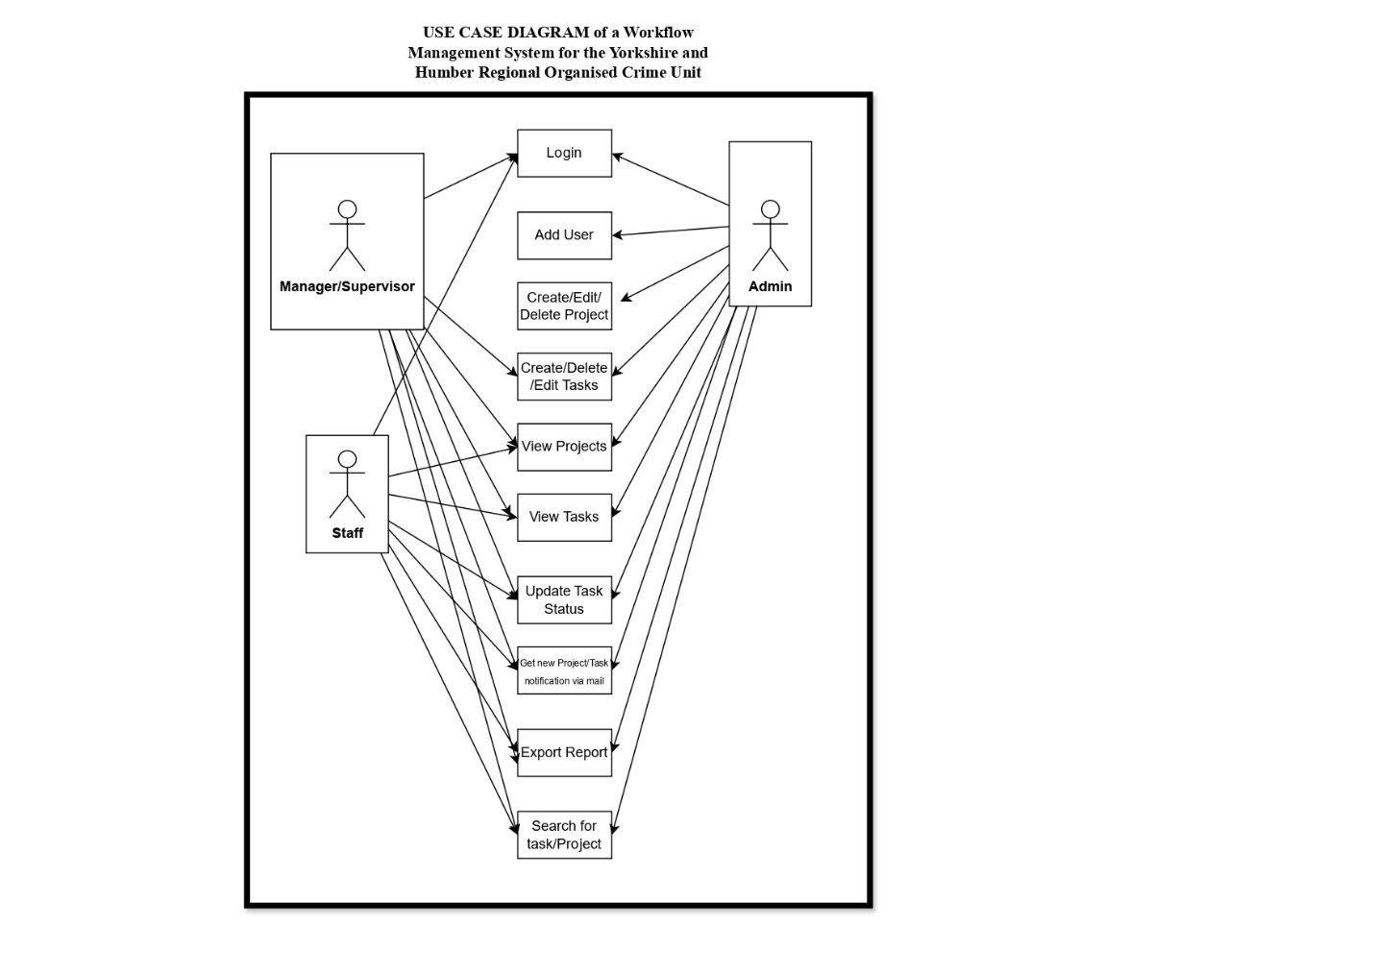

Figure 2: Use case diagram of the system

# System Flow Chart

A class diagram illustrates the structure of a system by depicting the classes, their attributes, methods, and relationships, providing a blueprint for software design. The figure 3 shows the Class diagram for the system.

Figure 3: Class diagram for the proposed system

# System Flow Chart

A flow chart diagram visually represents the sequence of steps or actions in a process or algorithm, aiding in understanding, analyzing, and communicating procedural logic. Figure 4 shows the flowchart of the system.

**Administrator**

**Manager/ Supervisor**

**User**

**Yes**

**Start**

**Is Login valid?**

**Enter Login Details**

**No**

Update task progress.

Manage Account

Generate Report and Receive email notifications.

Manage users, projects, and tasks. Generate Reports

Manage tasks and projects. Manage Account, Generate Report and Receive email notifications.

**Stop**

Figure 4: The flowchart of the system.

# Description of the system

Client Web Application Web Service consuming web service

Computer/ Mobile Device

Apache Server

PHP Language

Database

MySQL

<XML>

Request

HTTP

Request

HTTP

Response

<XML>

Response

Figure 5: Generic Architecture of the workflow management system (Source: Akinyede et al., 2021)

Through the front end, the user submits requests to the system. PHP, which is the intermediate tier, processes the requests. Verification, validations, manipulations, processing requests, and many more tasks are among the processing activities carried out. The intermediate tier relays the feedback from the back end to the front tier, where it is subsequently shown to the user.

HTML (Hyper Text Mark-up Language), which integrated CSS (Cascading Style Sheets) and JavaScript are the tools utilized for the front-end design. The programming language chosen as the intermediate tier is PHP (Hyper Text Preprocessor) which will create the link between the system's frontend and backend. MySQL serves as the backend database for the program which is where all necessary data about the system are stored.

**Operations of the System**

The system has three level of users: staff, manager or supervisor, and administrator. The administrator can access user details and is the only one with the authority to add a user, either a manager or a staff member. The administrator can register a staff member using their email address, password, first and last names, role, and avatar. The administrator can also remove or edit a user's details. The administrator can add a new project, set its start, and end dates, assign managers and members, and add projects. The administrator can also manage the project by adding, modifying, and terminating projects. A task is a subset of a project, each staff assigned to a project is assigned to the subprojects which are the tasks, an administrator can add tasks to each project and also manage the details of the tasks. An administrator can also generate reports of a particular project.

The manager, on the other hand, can perform functions such as creating a project for which he must be the supervisor, the supervisor can view and manager the projects and can create tasks under projects which they supervise. The manager can also assign tasks to staff members and manage the progress of the tasks and project. The manager can generate report of a task or project and manage their own personal profile, by editing their names, avatars, email and passwords.

Lastly, the staff can view the project and tasks under which they have been assigned but they can only update the progress of the tasks assigned to them. They can also manage their personal profile and generate reports of tasks assigned to them.

# Design of Initial Phase

During the system's initial phase, tasks and projects management modules were developed, among other fundamental features. The users were intended to find the system to be simple to use and intuitive.

A web-based interface made the system available to users from any internet-connected device, including PCs, tablets, and smartphones. Employees will be able to see the tasks and projects they have been allocated, managers will be able to supervise and create tasks and projects, and administrators will be able to manage user profiles, staff, and projects.

# User Feedback for First Phase

Seven users tested the system at the initial phase and provided feedback input. In general, the feedback gotten mentioned that navigating and using the system was simple. They valued the ease with which they could set up projects and tasks, examine the assignments, and keep track of their progress. They also cherished receiving email reminders when new tasks were created.

On the other hand, some users offered suggestions on how the system may be made better. For instance, some users said that there was no need to register an account because it would be used within an organizational structure and that they found the procedure of creating their account and entering their personal information to be perplexing. A few users also recommended that the task and project statuses be shown in a single view to enhance the system. Additionally, they proposed that employees do not have to be able to produce reports.

The reaction from the users throughout the system's initial phase was mostly good, with many praising the system's convenience and usability. The input offered insightful suggestions on how to enhance the system, which would be considered when designing the second stage of the project.

# Design of Second Phase

With an emphasis on improving the user experience for all users, the second phase of the system was developed on top of the feedback gotten from the first developmental phase. More flexibility and customization were included into the system to accommodate a wide range of user needs.

Features introduced in this phase includes the ability to generate reports exclusively for administrators and supervisors, to create users only for administrators, to observe project and task progress in the task bar, and to have sufficient summary for all user tiers displayed on the dashboard.

# User Feedback for Second Phase:

Seven users who tried the second phase of system provided feedback about the new features and options that let them customize the system to meet their unique needs, users discovered that the system was more versatile and adjustable than it had been in the previous phase.

The additional features, which included the necessary functionality included in the first phase system and gave users access to a comprehensive dashboard, were well-received by the users.

Users of the system in its second phase gave generally positive reviews, with many praising the expanded functionality and personalization choices. The input offered insightful suggestions on how to enhance the system, which will be considered in upcoming versions.

# Implementation of the System

The PHP programming language (version 7.0), MySQL server, and Apache web server were used in the development of the system. To operate the application on a computer, the following essential hardware has to be present:

Hardware Requirements:

A computer system with a minimum of

1. 1 gigabyte of RAM,
2. 80 gigabyte of hard disk drive

Software Requirements:

1. Web server software such as Apache
2. MySQL database server for storing and managing data.
3. A text editor or integrated development environment (IDE) for writing and editing code.
4. A web browser for testing and interacting with the web application during development and deployment.

Some of the snapshots of the system are shown below:

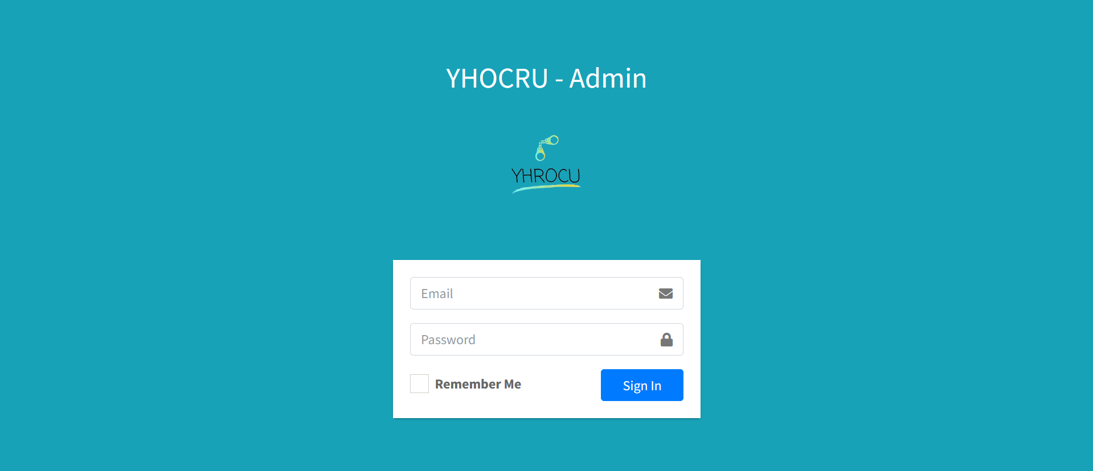

Figure 6: Login Page:

The figure 6 shows the login page where users can login into their account using their email and password.

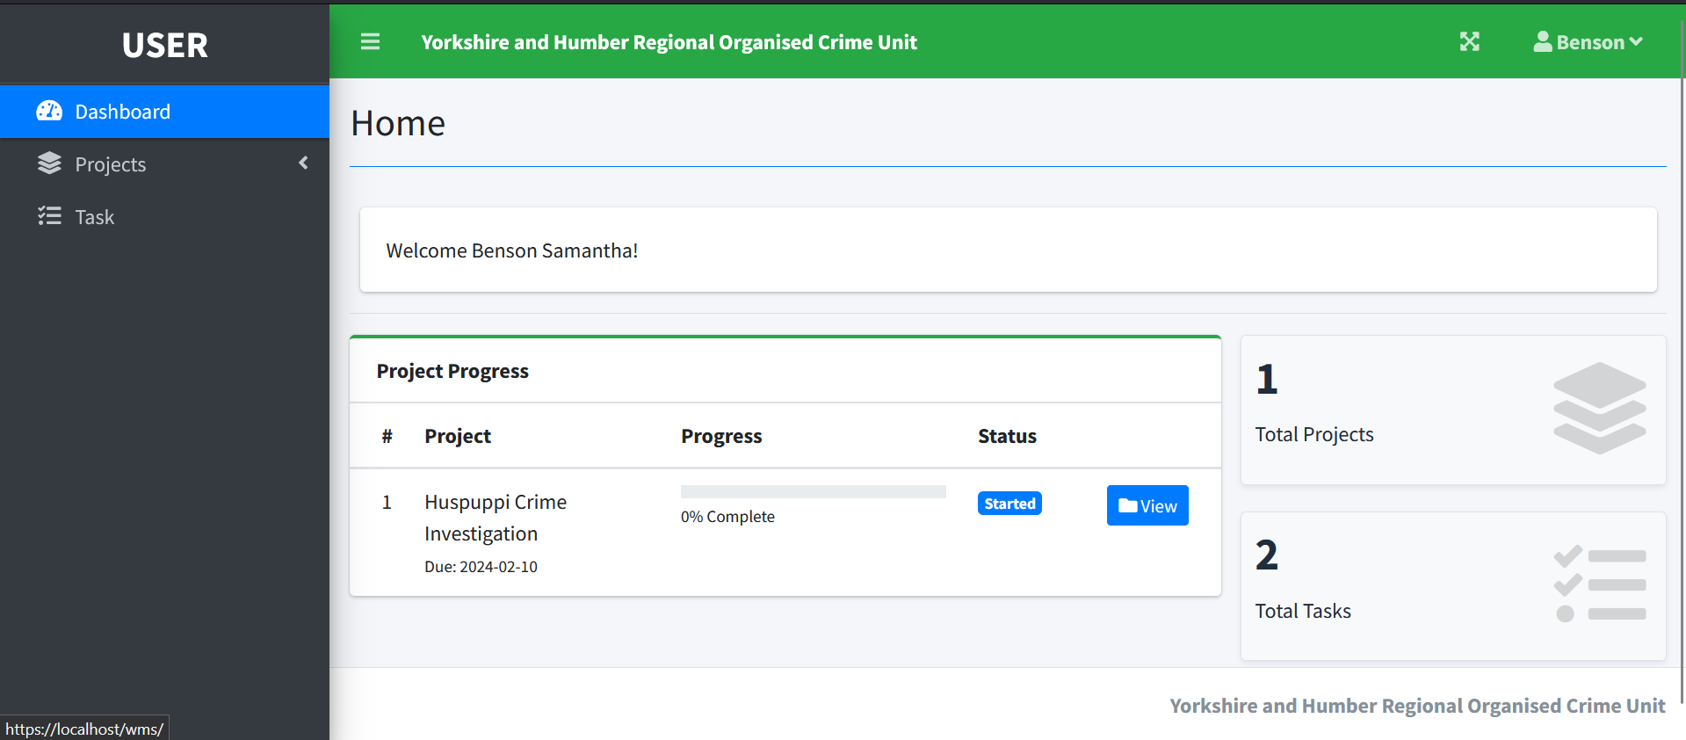 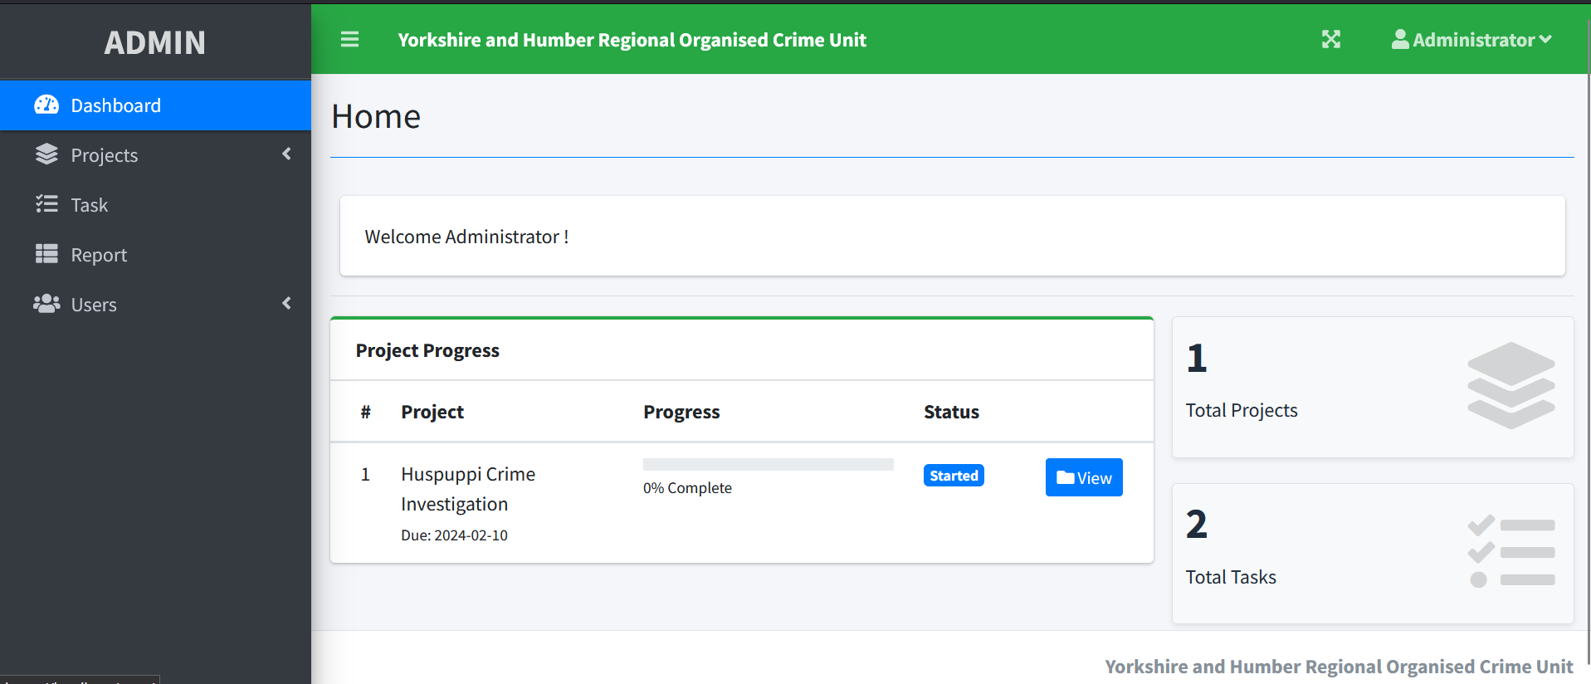

Figure 7: User Dashboard showing the staff and admin dashboard

Upon logging in into the system, the figure 7 shows the users dashboard which enables the users view their ongoing projects and its progress as well as navigate other menus.

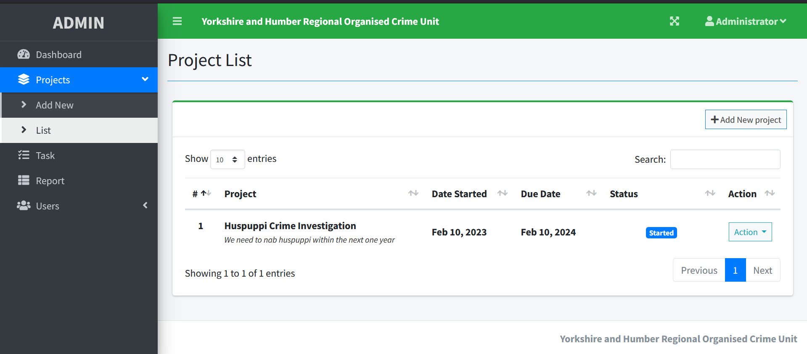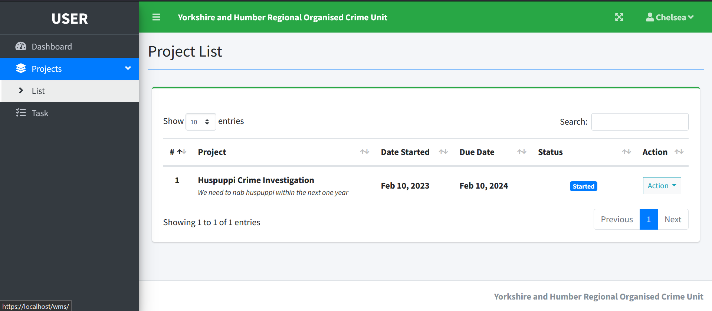

Figure 8a: View projects for admin and manager. Figure 8b: View projects for staff.

Figure 8 shows the current projects ongoing for the admin/manager and the staff and the manager, this page also enables an administrator or a manager to add a new project and take actions like close or update an existing project while the staff can only view the project details.

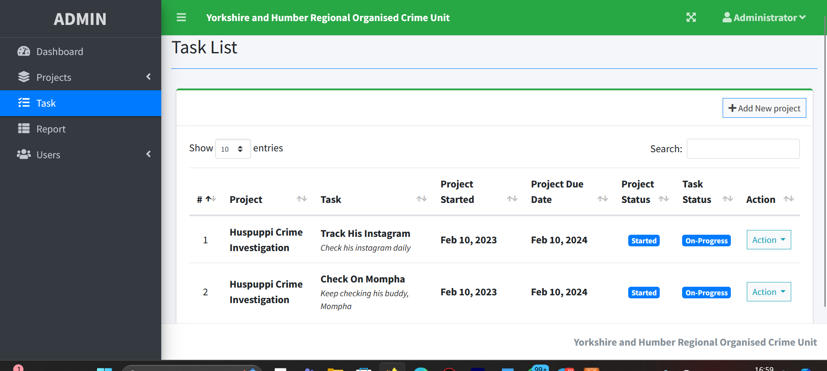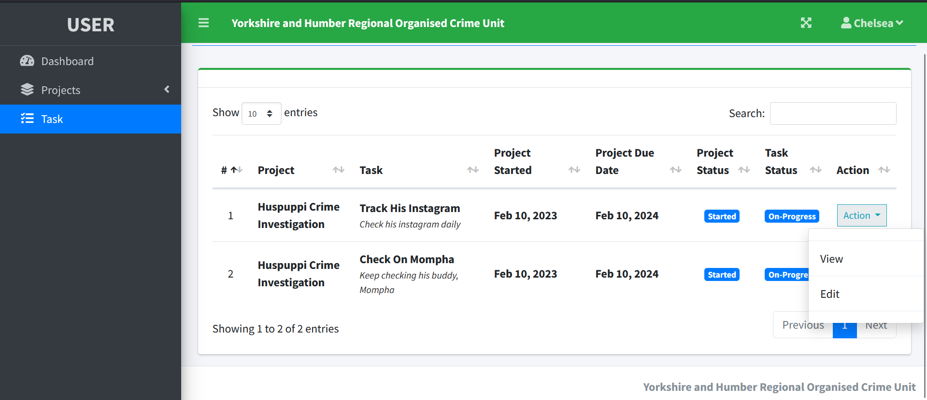

Figure 9a: Tasks page for admin/manager. Figure 9b: Tasks page for Staff.

Under each project are different task that the manager or administrator can assign a staff to, this tasks page allows a manager and administrator to manage a task while a staff can only view a task and update the progress of an assigned task.

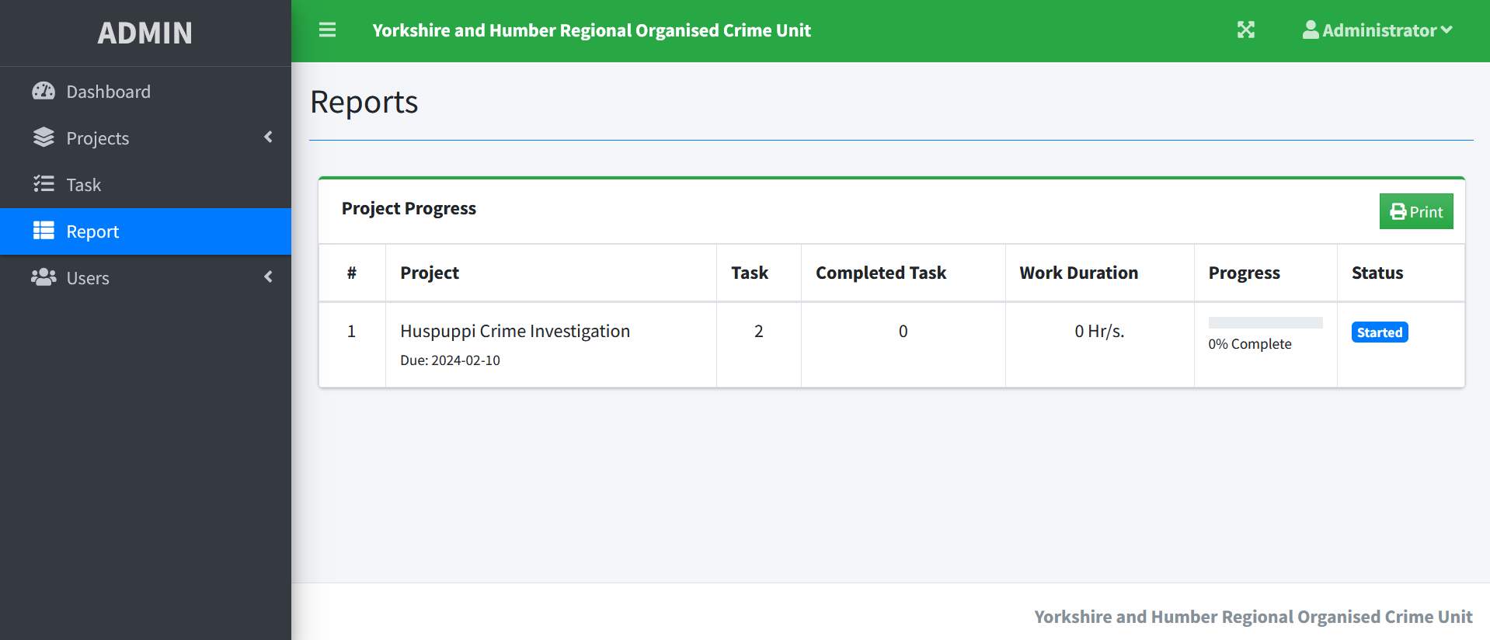

Figure 9: Generate Report.

The generate report page is only available to the administrator and manager where they can view the details of the current projects and print to pdf format the reports.

**Ethical Considerations:**

Workflow management solutions are essential for improving productivity and simplifying organizational procedures. However, the creation and deployment of such systems involve important ethical problems, particularly with data security, user privacy, and transparency.

Developing workflow management systems with strong data security safeguards to protect sensitive data is a major aspect to consider amongst ethical issues. Strict password hashing algorithms were employed for this project's secure authentication to guard against unauthorized access and data breaches.

When gathering user feedback for the first and second design phases, privacy was also protected. Users' informed consent regarding the use of the feedback they have provided was obtained, and the way the system would use their information has been made transparent.

**Conclusion**

Automating a workflow system can increase productivity, decrease jobs that are missed thanks to email reminders, and improve efficiency. A first phase of the system was designed which included task and project management alongside authentication and report generating modules. However, after discussion with users and industry professionals, additional features were added to the system, which improved its robustness and suitability for usage. With a third design phase, the system might be expanded to include more functions in response to user feedback.

# 

# References

Akinyede, R. O., Balogun, T. E., Rotimi, A. B., & Famodimu, O. B. (2020). A customer-centric application for a cinema house. *Applied Computer Science, 16(2)*, 68-79.

Bowers, J., Button, G., & Sharrock, W. (1995). Workflow From within and without: technology and cooperative work on the print industry shopfloor. *In Proceedings of the fourth European conference on computer-supported cooperative work* (pp. 51–66). Kluwer Academic Publishers.

Dourish, P. (2001). Process descriptions as organisational accounting devices: the dual use of workflow technologies*. Computer Supported Cooperative Work (CSCW), 10(1),* 52–60.

Goebl, W., Messner, K. J., Schwarzer, B., & Ag, G. S. (2001). *Experiences in Introducing Workflow Management in a Large Insurance Group.*

Halsted, M., & Froehle, C. (2008). Design, implementation, and assessment of a radiology workflow management system. *American Journal of Roentgenology, 191(2),* 321–327.

Küng, P., & Hagen, C. (2007). The fruits of business process management: an experience report from a Swiss bank. *Business Process Management Journal, 13(4),* 477–487. doi: 10.1108/14637150710763522

Li, M.-F., Tsai, J. C., Chen, W.-J., Lin, H.-S., Pan, H.-B., & Yang, T.-L. (2013). Redefining the sonography workflow through the application of a departmental computerized workflow management system. *International Journal of Medical Informatics, 82(3),* 168–176. doi: 10.1016/j.ijmedinf.2012.06.001

Reijers, H. A., Vanderfeesten, I., & van der Aalst, W. M. (2016). The effectiveness of workflow management systems: A longitudinal study. *International Journal of Information Management, 36(1)*, 126-141.

Reijers, H., & Van der Aalst, W. M. P. (2005). The effectiveness of workflow management systems: predictions and lessons learned*. International Journal of Information Management, 25(5),* 458–472. doi: 10.1016/j.ijinfomgt.2005.06.008

Schmidt, J., Meetz, K., & Wendler, T. (1999). Workflow management systems—a powerful means to integrate radiologic processes and application systems. *Journal of Digital Imaging, 12(2)*, 214–215.

References to other documents

Code: [OyinkansolaAfolabi/Workflow-management-system: An assignment for a Workflow management system for non-crime related activity in Yorkshire and Humber Regional Organised Crime Unit (github.com)](https://github.com/OyinkansolaAfolabi/Workflow-management-system)  
Demo: [OyinkansolaAfolabi/Workflow-management-system: An assignment for a Workflow management system for non-crime related activity in Yorkshire and Humber Regional Organised Crime Unit (github.com)](https://github.com/OyinkansolaAfolabi/Workflow-management-system)  
Gantt Chart:

NDA’s: [Workflow-management-system/NDA.docx at main · OyinkansolaAfolabi/Workflow-management-system (github.com)](https://github.com/OyinkansolaAfolabi/Workflow-management-system/blob/main/NDA.docx)